Team Registration Instructions - Spring 2026

The same link is used for both team and player registration:
https://www.rampregistrations.com/login?v3=00e51c2a

Team Registration will be open March 2 - 11, 2026. You must attend a Captain’s Meeting in order to have your team registration approved. Player Registration will open March 12 - 30, 2026 for your players to join your team.

We strongly recommend bookmarking this page, as you will use it to manage your team and print team rosters for your games each week.

- The link will take you to the league login page. This is a new system for IFASA so you will need to create a new account this season. To create a new account, click the highlighted link below:
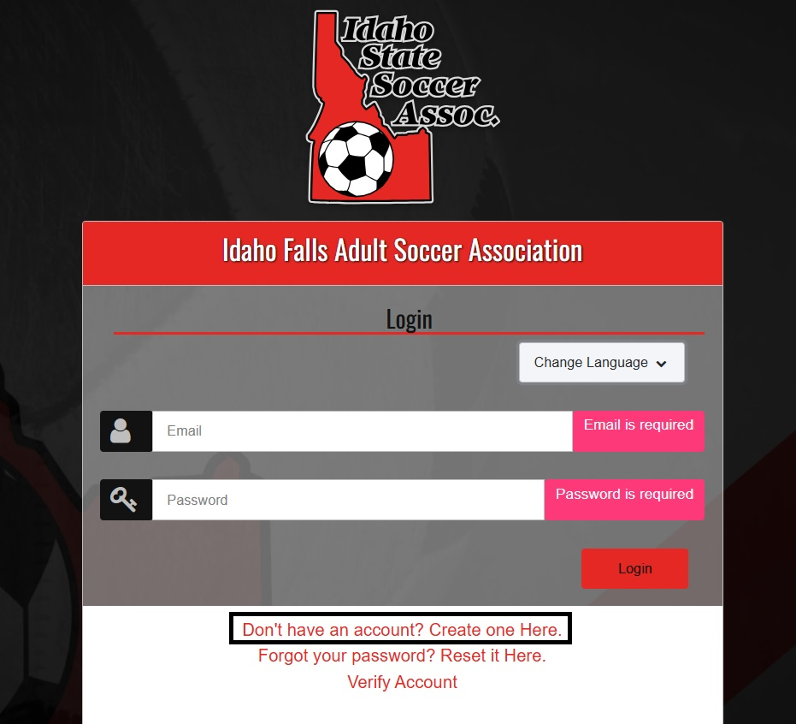

- The system will prompt you to input an email address and password. Once you submit that information, it will send a verification code to your email address. Please make sure that you can access the email address you use to sign up.
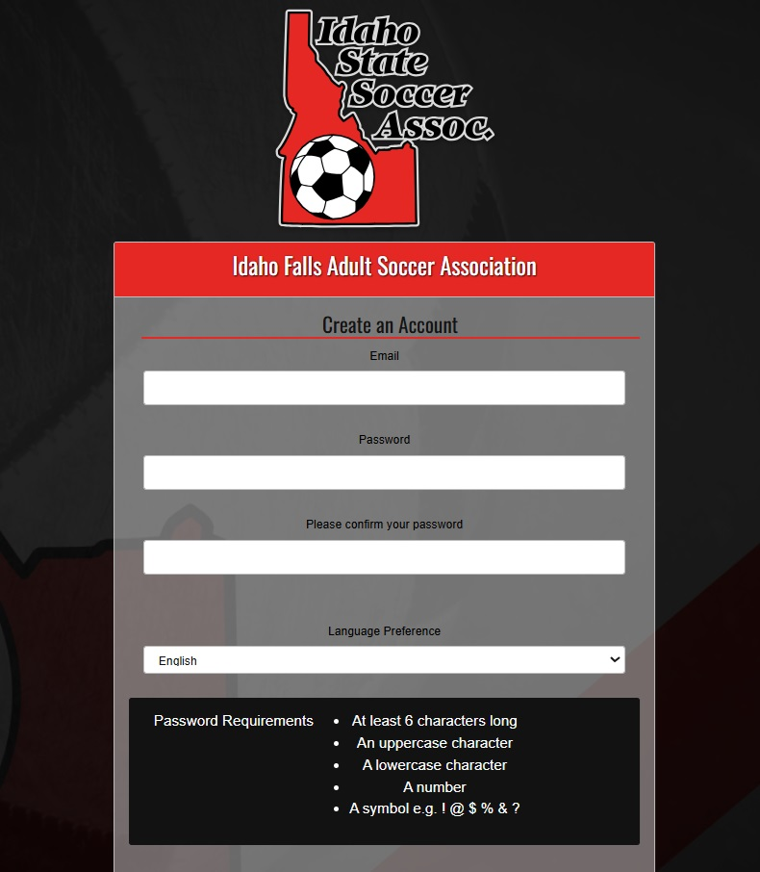

- Log in to your account with your email address and password, and enter the verification code that was emailed to you.

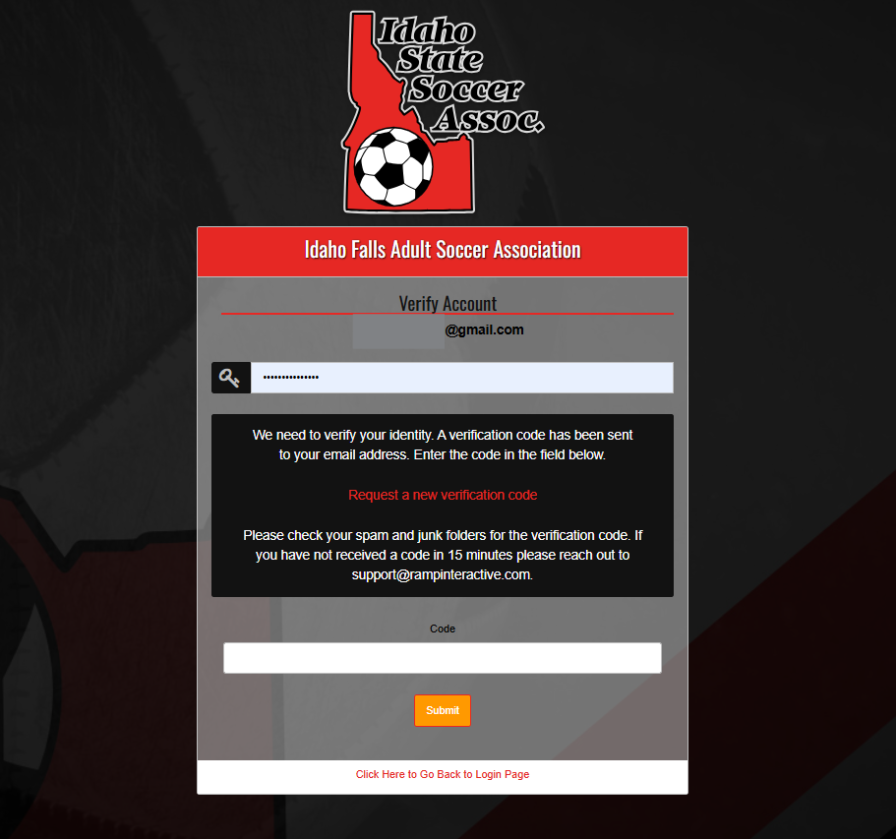

- Once you have logged in, you will be shown the main screen registration. You have until March 11, 2026 to register your team for the Spring 2026 session. Click the “Team Registration” button.

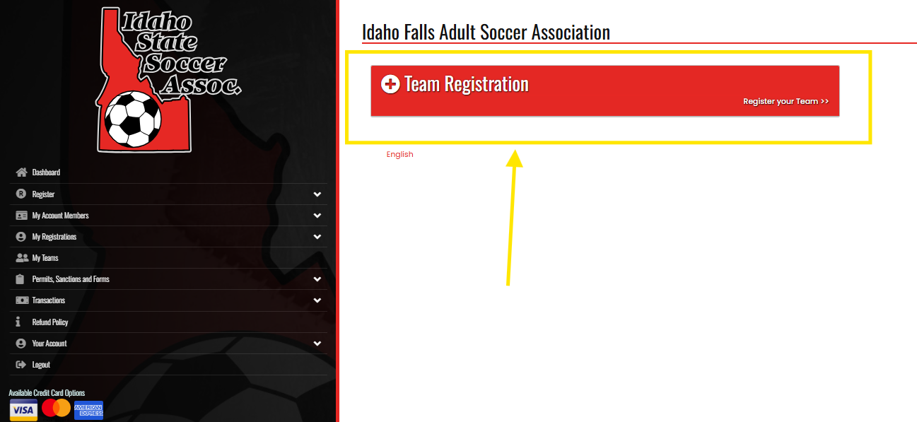

- The next screen will allow you to enter in your team information for registration. First, select the division your team will be registered in (Women’s 11v11 or Men’s 7v7).

You then need to register yourself as the team captain. Under ‘Choose Account Member to be the Team Captain’, select ‘Add an Account Member’. Since you are registering a team for the first time, you will need to enter in all your personal information. In subsequent seasons, all your information will be saved, and your name will be in the drop down menu. You can make changes to this information in the future if needed. You do not need to be a player on the team to captain and register a team.

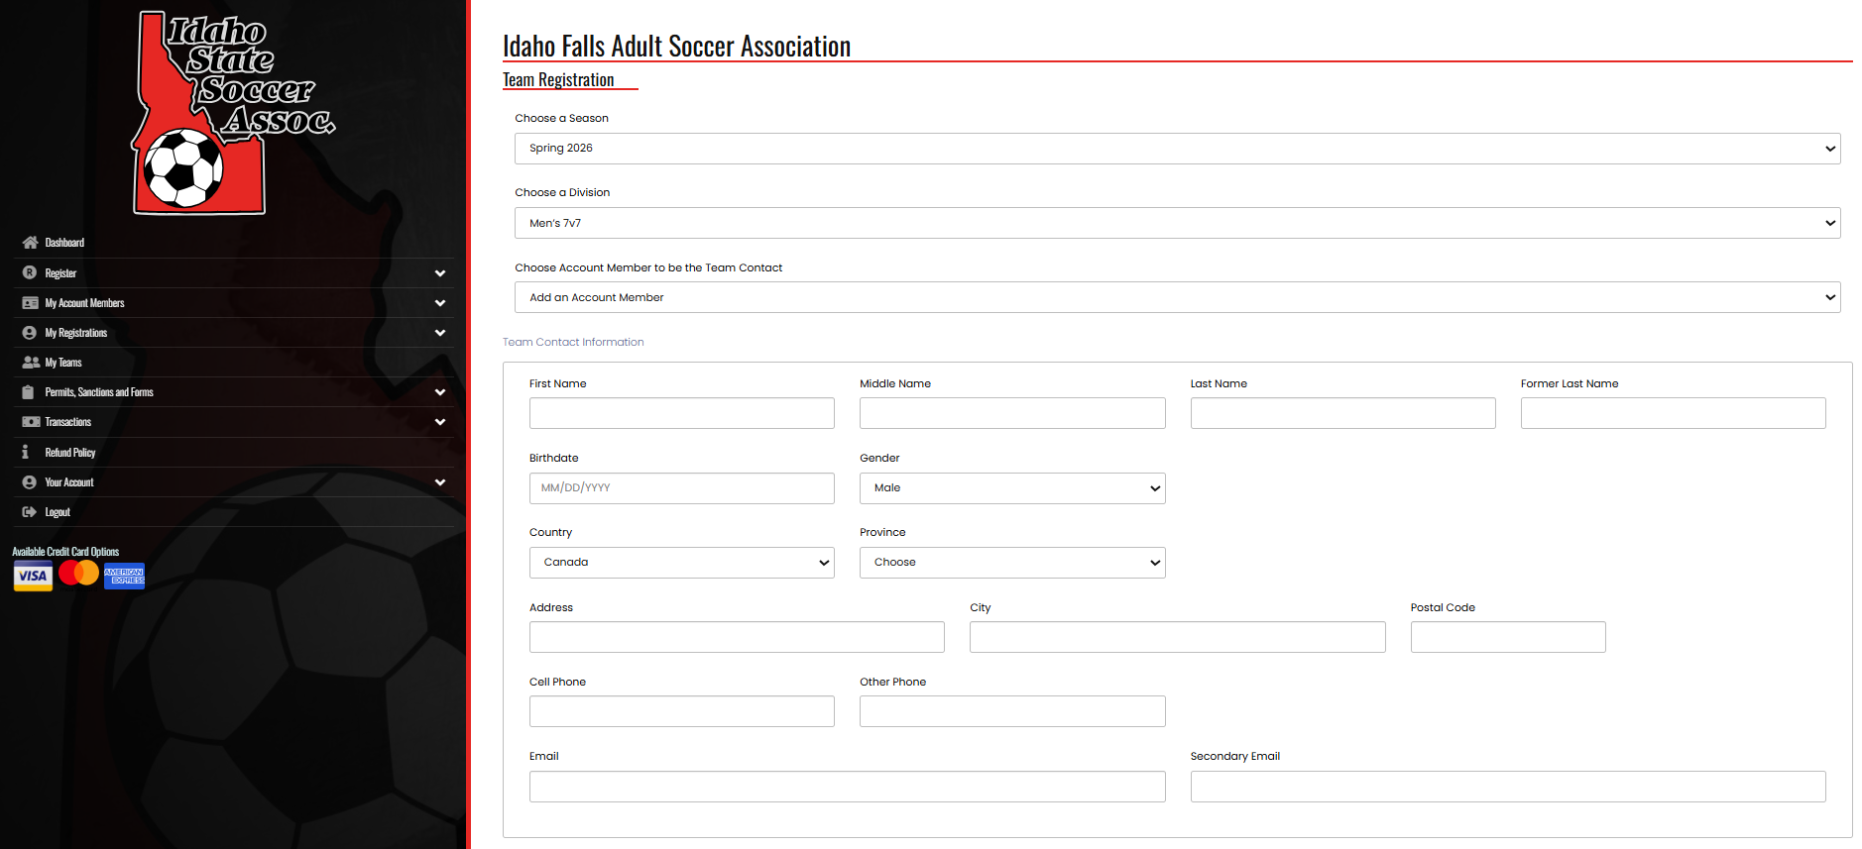

- In the last box you will fill out your team name. Since you are registering a team for the first time in this system, on the ‘Team’ drop down menu, select ‘Create a New Team’. A box will appear in which you enter your team name. In future seasons, the system will remember your team name and you will be able to select it in this drop down menu.

- In the next window, you will be shown all the waivers required by the state and the league in order to participate. Read these carefully and sign in the 5 boxes for each of the waivers by drawing with the mouse on a computer or signing with your finger on a tablet or mobile phone. Click the “I am the age of majority…” box and click “Continue”.

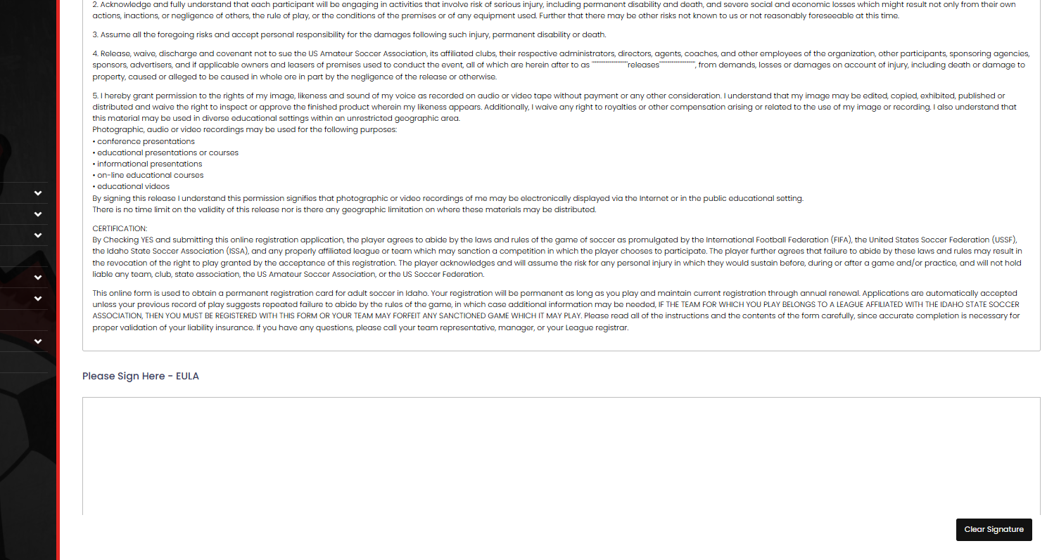

- On the next screen, you will then need to enter your team jersey color.

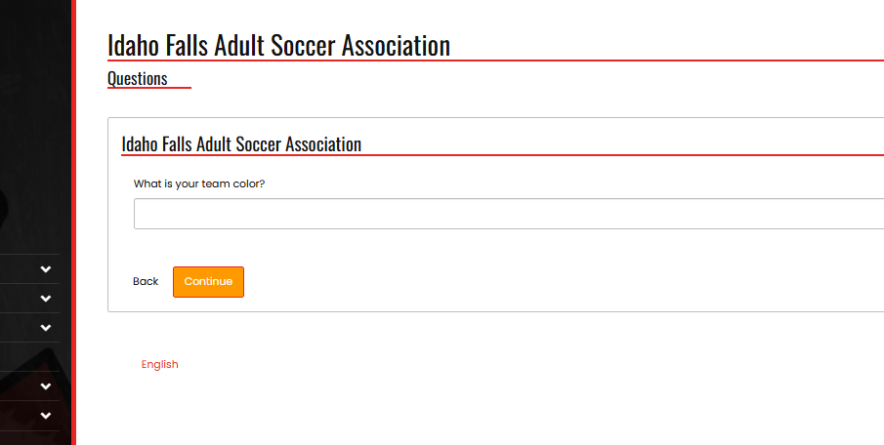

- The next window will show you a blank team roster. As the Team Contact, put your own name and email address into the first line, and tick the “Team Contact” check box. Don’t worry about filling in your teammate information at this time, you can also enter in this information at a later date from the team manager page. (If you have your teammate email addresses at hand, then feel free to enter them below yours).
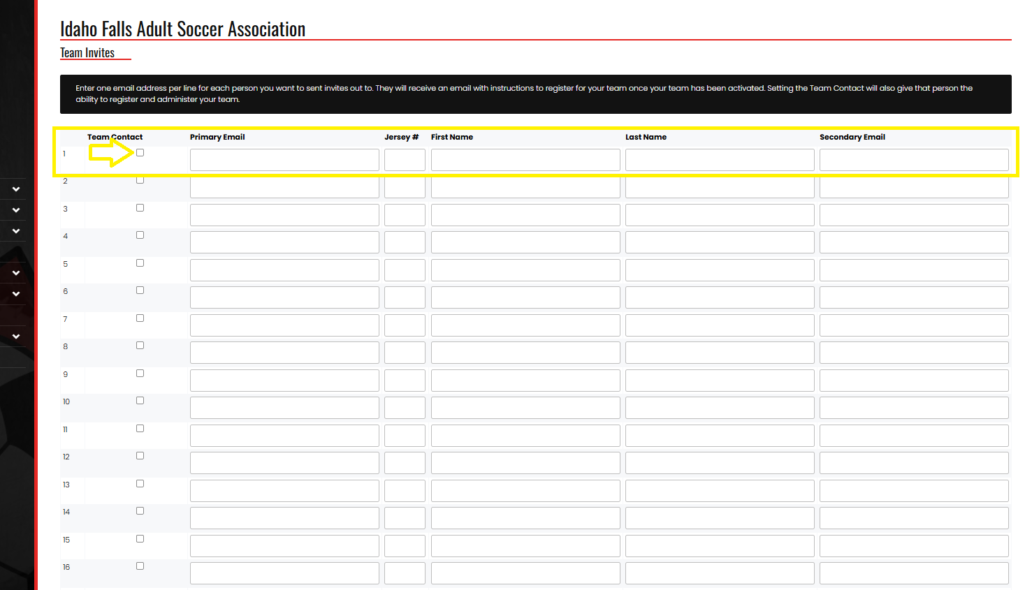

- Click ‘Continue’ to be shown a summary screen with the information filled out on the previous pages. Check that all of the information is correct, and then click the ‘Submit Registration’ button at the bottom of the screen.

- This will take you to the confirmation screen. At the bottom of the page, you will find your team invite code and invite URL. In the future, you will be able to obtain this information again from your team manager page.Team members will require an Invite Code or link in order to join your team.

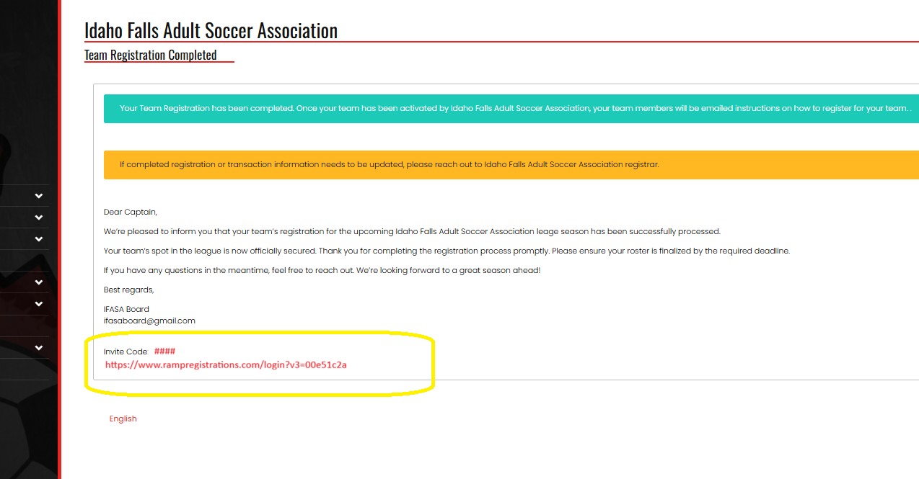

- We strongly recommend using the system to send invite codes to your teammates via email on your behalf. If you use the system, in future seasons, your team players and email addresses will be automatically populated with all players you previously sent invites to. You can also choose to send the URL and/or invite code via any method you like (e.g., text message, What’sApp, Email, etc.).

- To manage your team, click on the ‘My Teams’ button on the menu bar on the lefthand side of the screen.

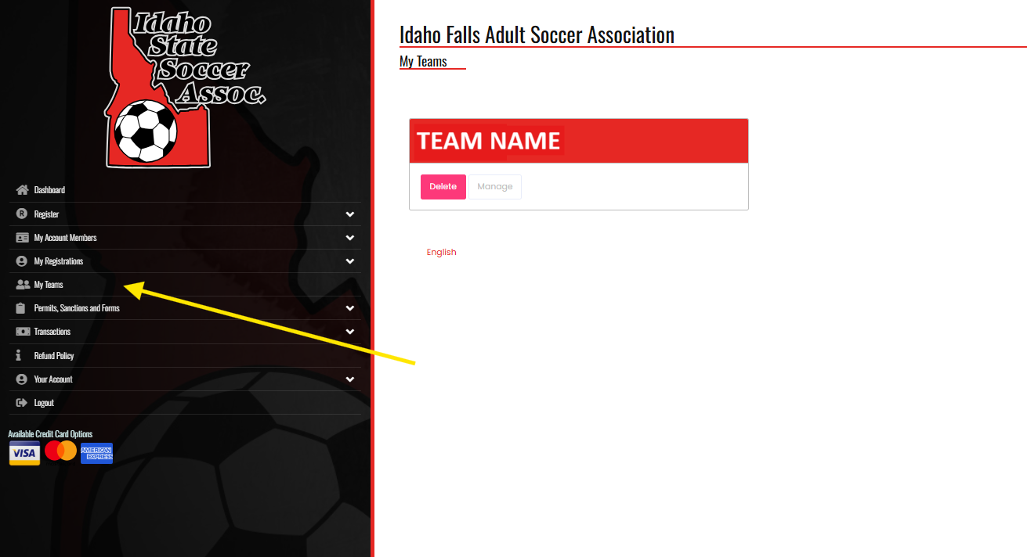

- Under your team name, select “Manage’,

- When your team appears, select ‘Manage’ again. Note the subsequent ‘Manage’ page can take some time to load.

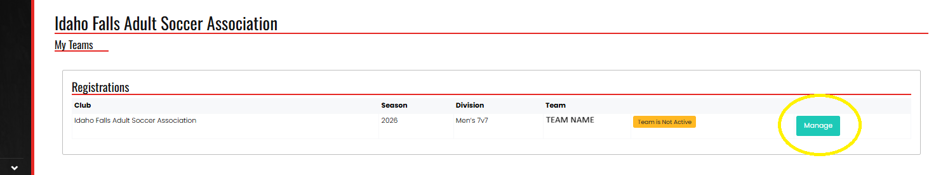

- Once the ‘Manage’ page loads, you will find your team access code and URL at the top of the page.

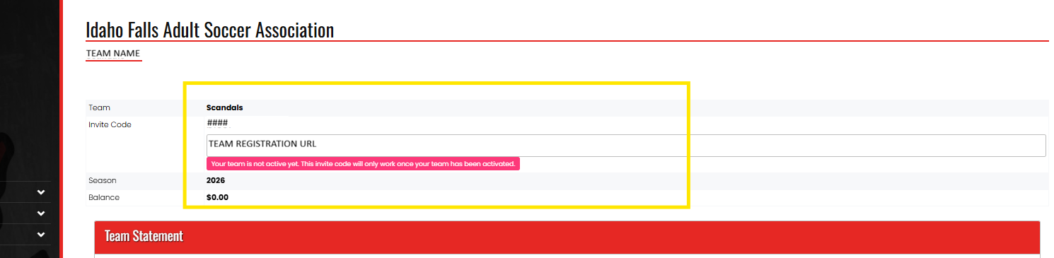

- At the bottom of the page, you will find your team roster from step 9. Here, you can fill in your team member’s names and email addresses to have the system notify them with your team invite code and URL. After the email addresses are entered, click the ‘Update Team Invites’ and ‘Send Invite Emails’ buttons at the bottom of the page. This invitation will be sent when you press the button, but note that the official Player Registration opens on March 12, 2026. If you do not want to use the system, you must provide the Invite Code and/or URL to your teammates via another method.
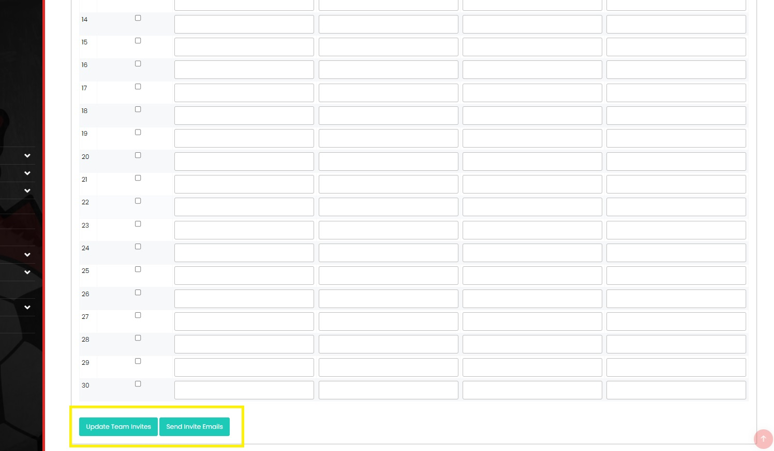

- Congratulations, you have successfully registered your team! Please ensure that your players complete their registration by March 30, 2026.

