Player Registration Instructions - Spring 2026

Find the link below for player registration:
https://www.rampregistrations.com/login?v3=00e51c2a

Player registration will be opened on March 12, 2026. All players must be registered by March 30, 2026 in order to participate in the first game of the season.

- The link will take you to the league login page. This is a new system for IFASA so you will need to create a new account this season. To create a new account, click the highlighted link below:

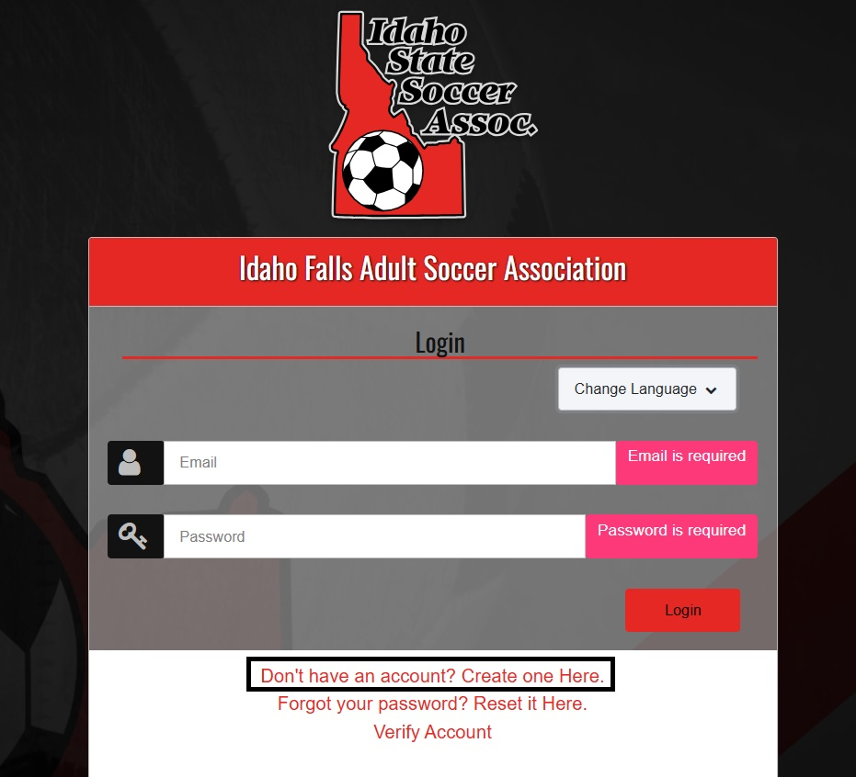

- The system will prompt you to input an email address and password. Once you submit that information, it will send a verification code to your email address. Please make sure that you can access the email address you use to sign up.
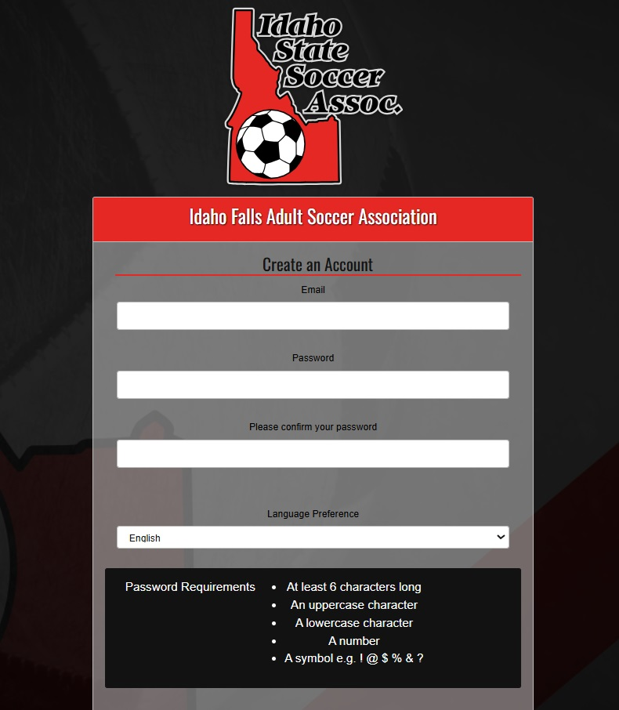

- Log in to your account with your email address and password, and enter the verification code that was emailed to you.

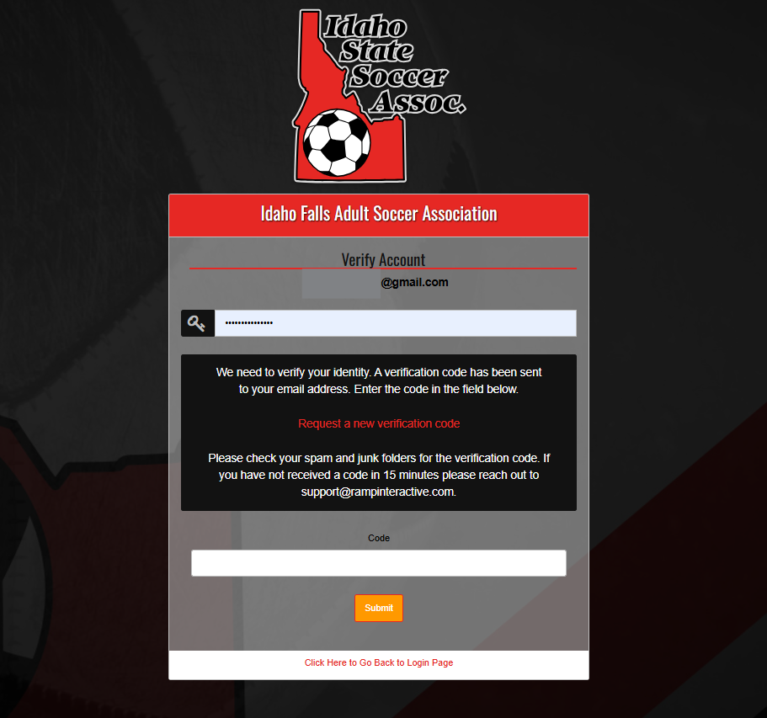

- Once you have logged in, if you used the link at the beginning of this document, then you will be shown the main screen registration. If your captain provided you with an Invite link, then you will automatically skip to step 5. If not, then starting on March 12, 2026 you will see the ‘Register to a Team’ button, click this.

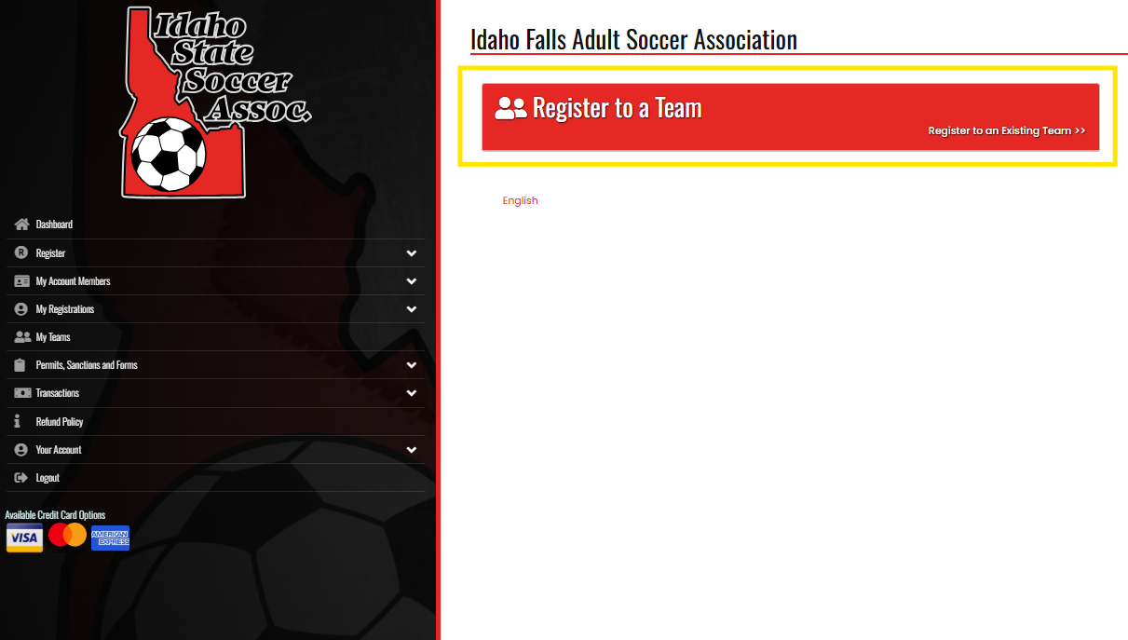

- On the next screen, you will be prompted to enter your team’s Invite code. You must be provided this by your team captain in order to join a team. Enter your Invite Code and press ‘Find Team’. If you do not know your team Invite Code, reach out to your team captain. If you do not have a team, then fill out the Free Agent Form : https://docs.google.com/forms/d/e/1FAIpQLScxfoflHsUO8-YIQvopcTHzwVwybCWQCRg5AaooVopJlSVc-Q/viewform and the IFASA Board will try to place you on a team.

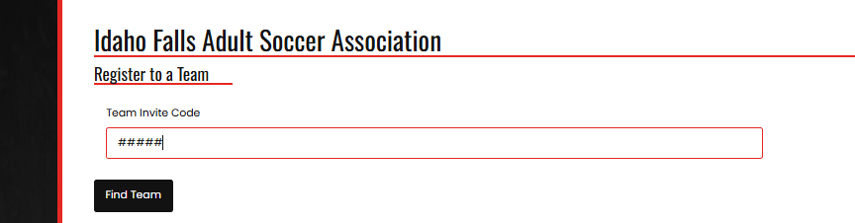

- Below this, you need to pick a person from your account to register to the team. If this is your first time registering, click ‘Add an Account Member’ and enter in your personal information. If you have already done this, then simply select your name from the drop down menu. All relevant information will be pre-filled from previous answers. You can edit this information if needed.

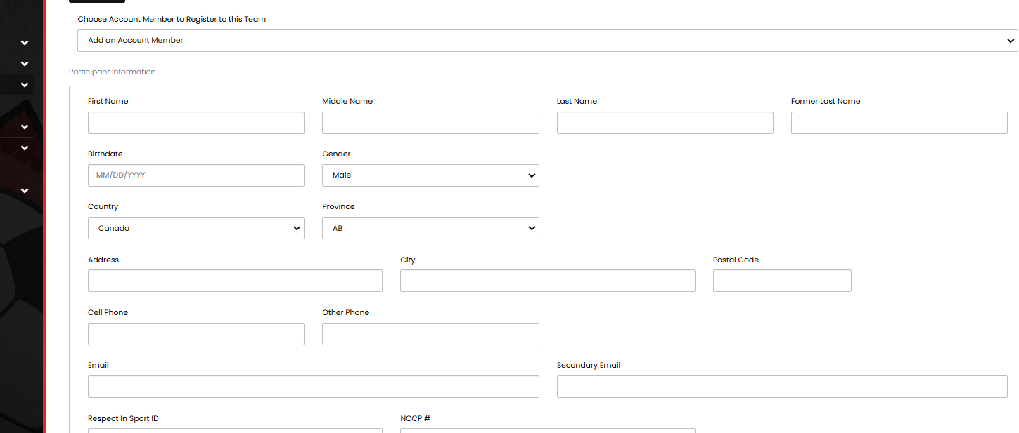

- Once your team has been found, you will be prompted to select a role. Choose ‘Player’ or ‘Staff Member’ as appropriate. If you would like to register as both a player and a staff member, then you will need to repeat this process and select the other role.

- Below your information, you will see two fees that will need to be paid to complete your registration. The first fee ($55.00 USD) is the cost per player per team to play in the IFASA league. The second fee is for your insurance from the State ($30.87 USD). You will only need to pay the State fee once per calendar year. Therefore, if you play in the Women’s or Men’s league in the Spring, you do not need to pay the State fee again for the Coed Summer season. Press ‘Continue’ to move to the next step.

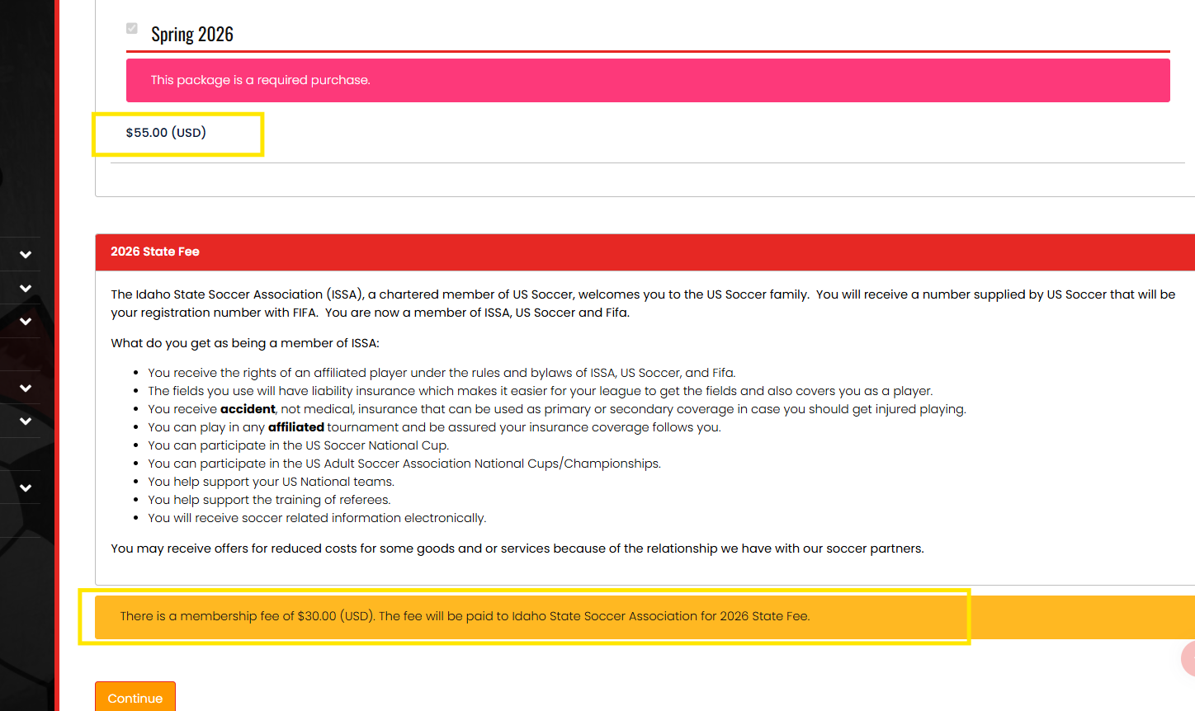

- In the next window, you will be shown all the waivers required by the State and the league in order to participate. Read these carefully and sign in the 5 boxes for each of the waivers by drawing with the mouse on a computer or signing with your finger on a tablet or mobile phone. Click the “I am the age of majority…” box and click “Continue”.

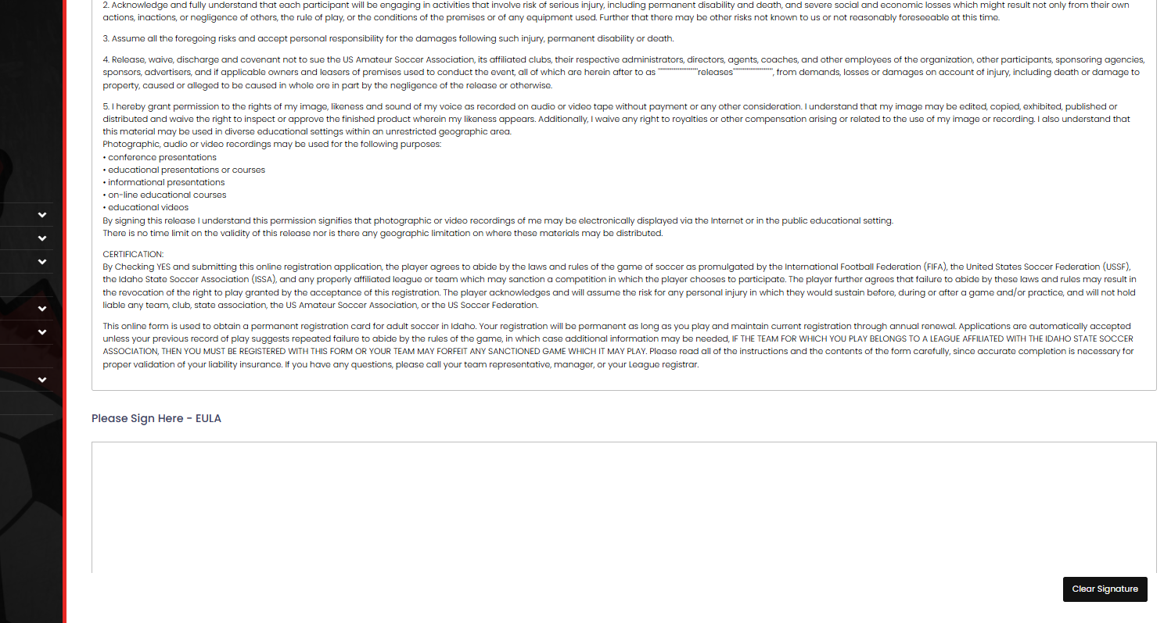

- The system will then ask you to upload two photos: The first is a clear passport-style photo of your face, and the second is a clear picture of the front of your Government Issued ID.

For the passport-style photo:
- Must be a photo of only your head
- Your face must be centered and clearly visible
- Photos must be full color
- No hats, sunglasses, masks, etc.
- No other people or pets in the photo

For the Government Issued ID:
- Can be a passport, driver’s license, or military ID
- Must show an image of your face
- Must have your date of birth clearly visible and legible

Failure to comply with these instructions may result in delays in your registration. Upload the appropriate files. The filename of your photo will appear, but you will not see a preview of your photo. Click ‘Continue’.

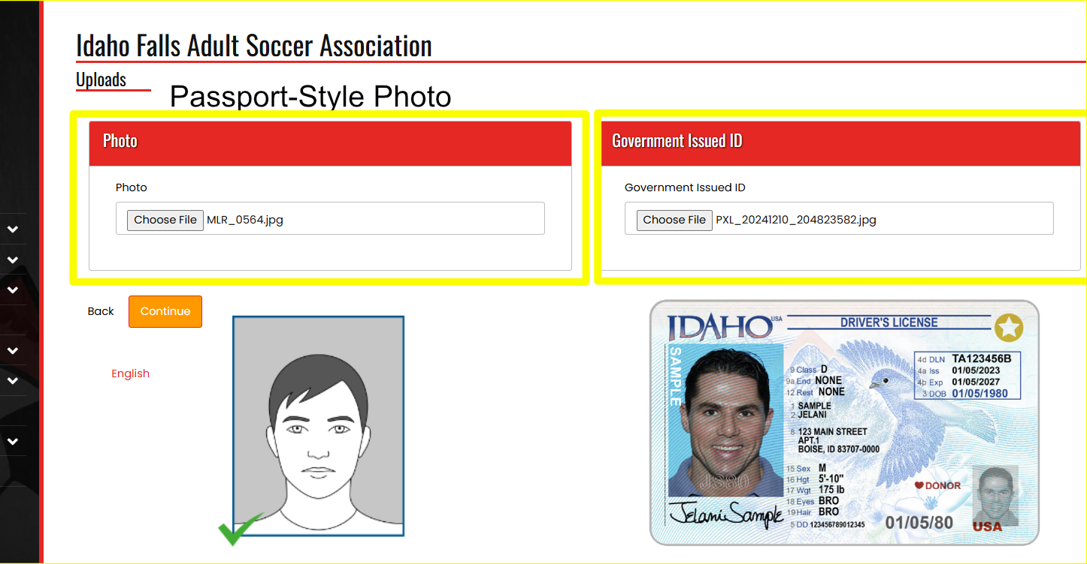

- On the next screen, you will then need to enter an Emergency Contact (First and Last Name) and their phone number. You must enter these to continue.
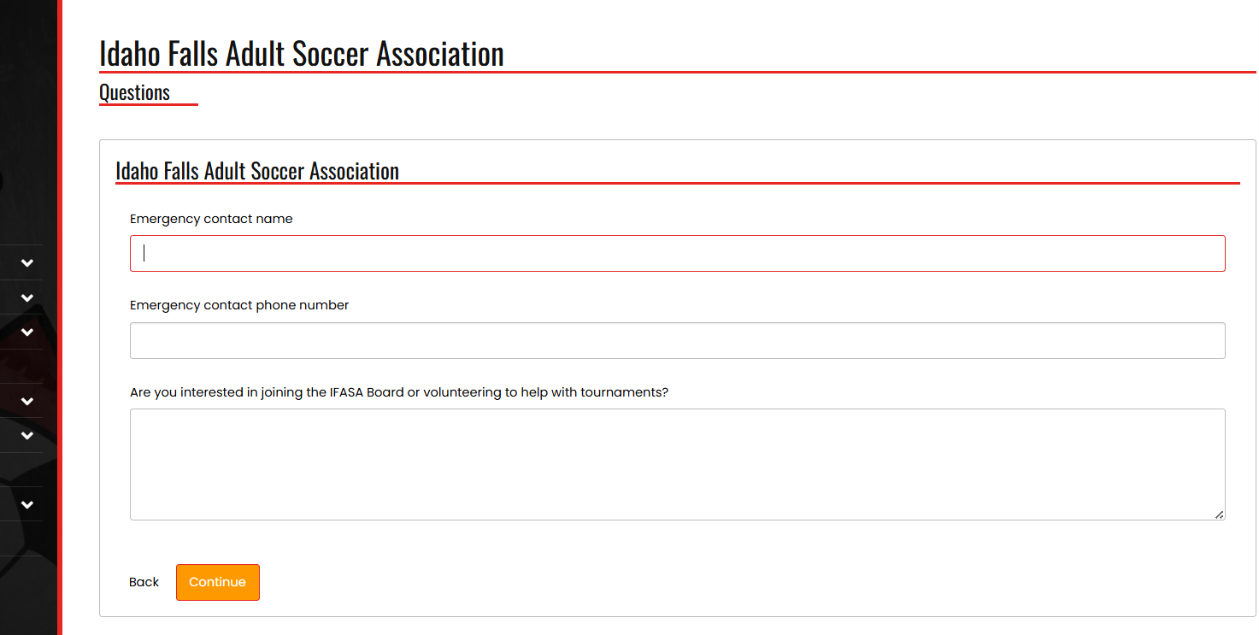

- Click ‘Continue’ to be shown a summary screen with the information filled out on the previous pages. Check that all of the information is correct, and click ‘edit’ if anything needs to be changed.

Scroll down to see the payment information. You will see two fees that will need to be paid to complete your registration. The first fee ($55.00 USD) is the cost per player per team to play in the IFASA league. The second fee is for your insurance from the State ($30.87 USD). You will need to enter your payment information for each of these separately.

You will only need to pay the State fee once per calendar year. Therefore, if you play in the Women’s or Men’s league in the Spring, you do not need to pay the State fee again for the Coed Summer season. Please check the amounts before proceeding with payment. If everything looks correct, enter your credit card information and click the ‘Submit Registration’ button at the bottom of the screen.
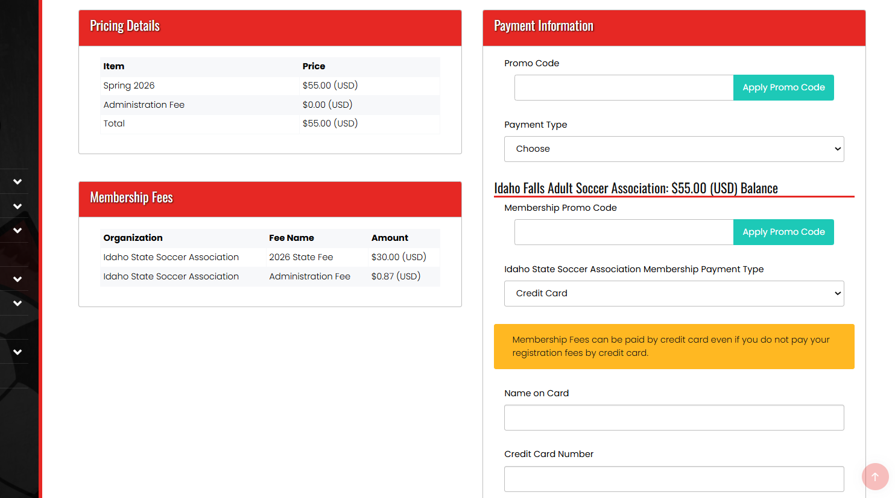

- If your payment is successful, you will be taken to a registration confirmation screen. You should also receive an email confirmation. If you are unable to register, please carefully read through all of the instructions and try again. Please note that Player Registration opens from March 12 - 30, 2026. If you are still having problems registering, reach out to ifasaboard@gmail.com.

